GANs for Data Augmentation and Privacy

Overview of GAN Applications

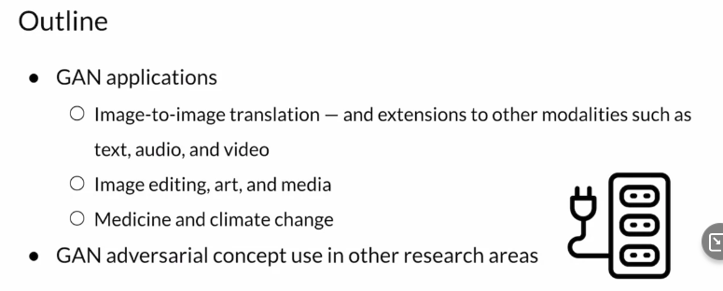
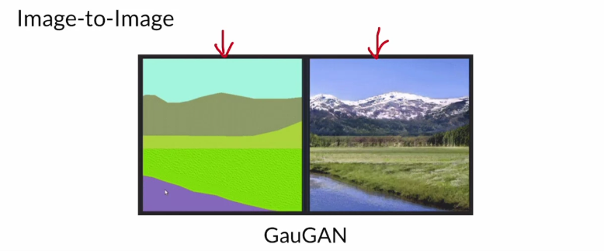
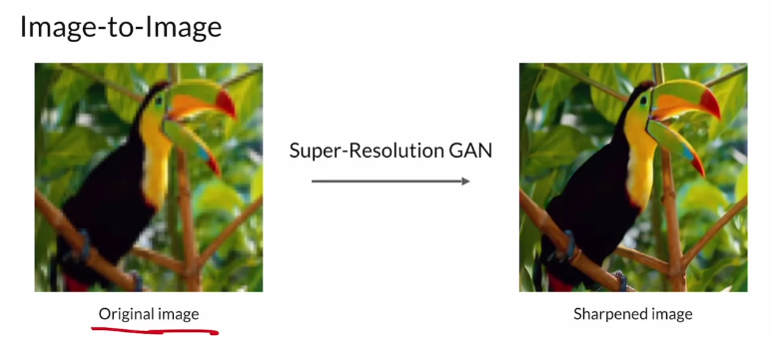
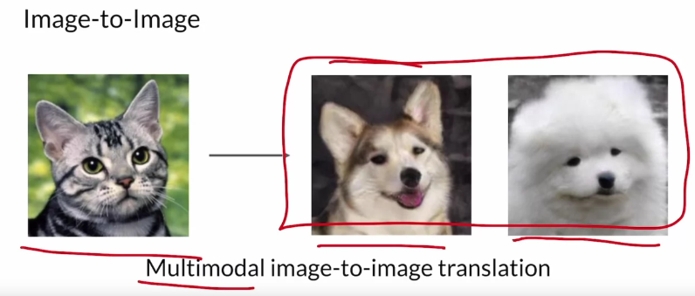
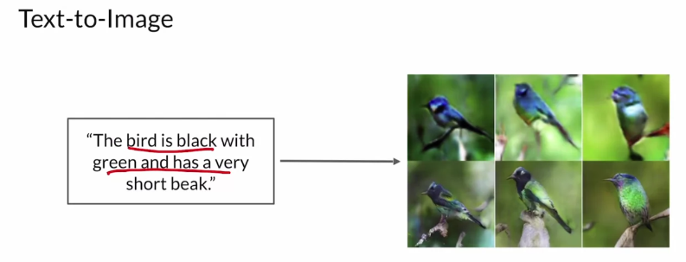

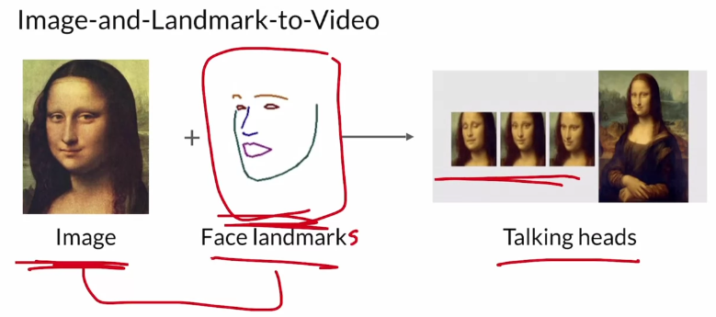
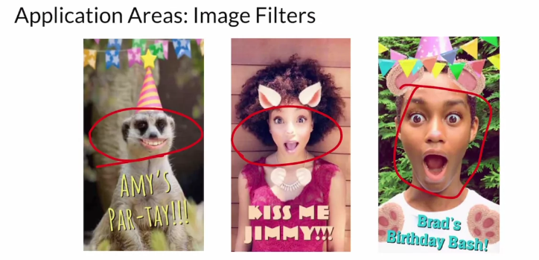
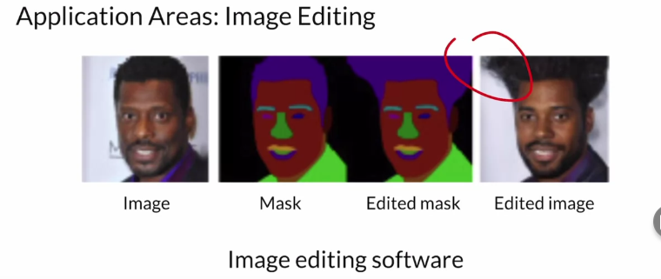

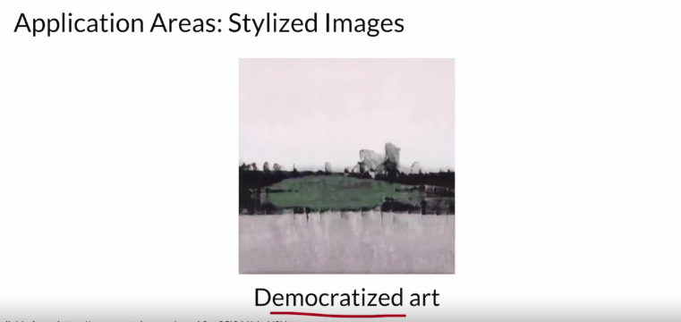
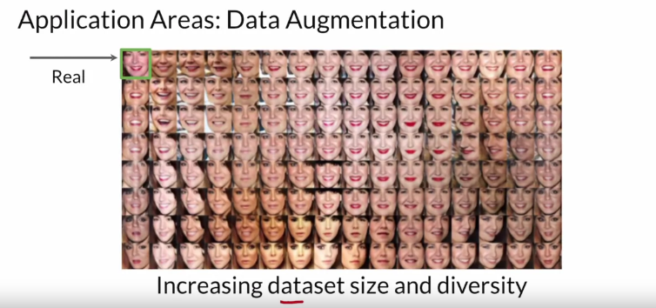
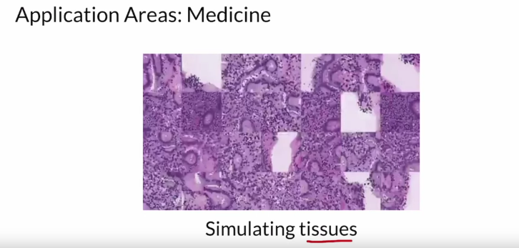
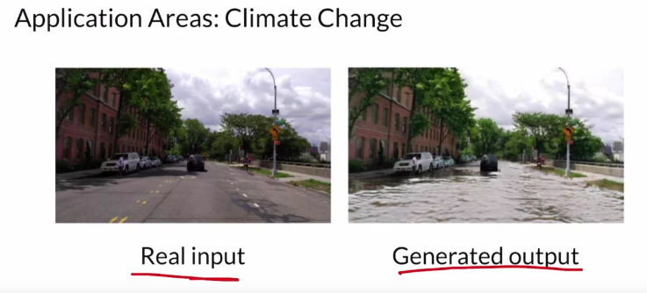
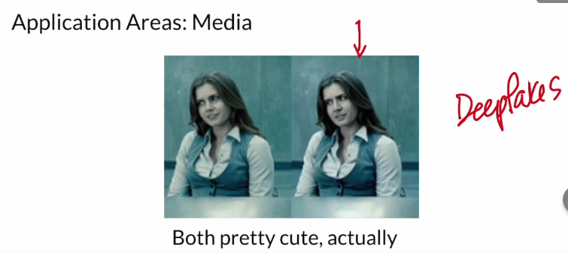
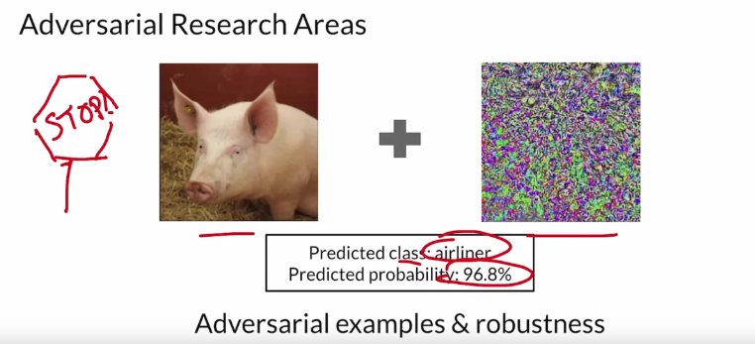

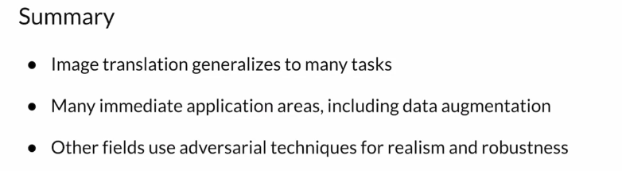

Data Augmentation: Methods and Uses

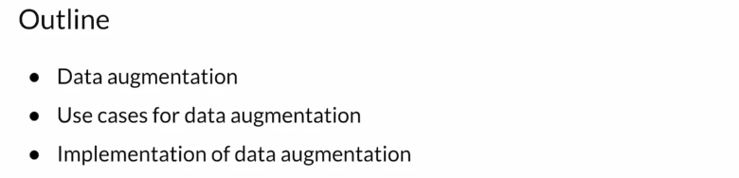
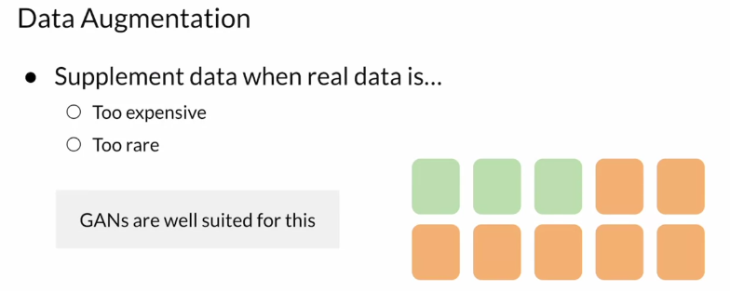
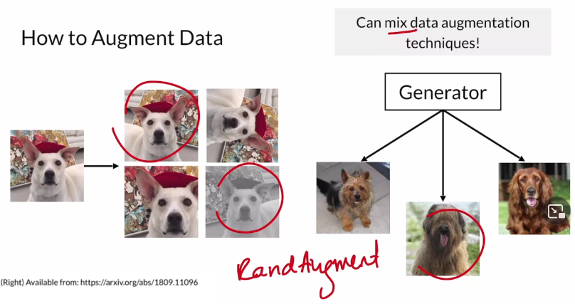

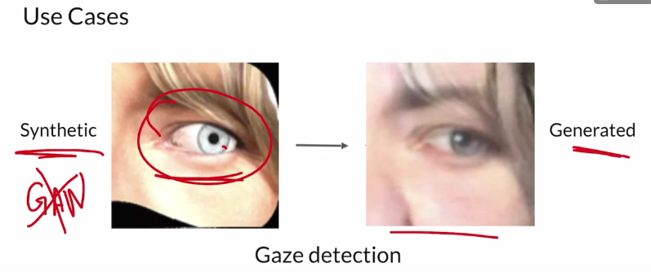
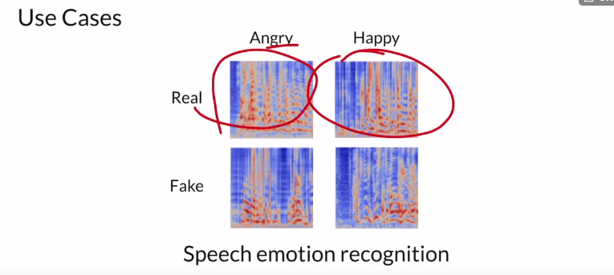
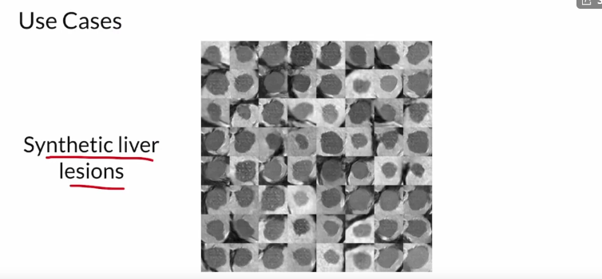

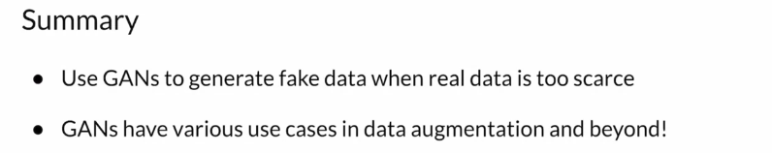

Data Augmentation: Pros & Cons

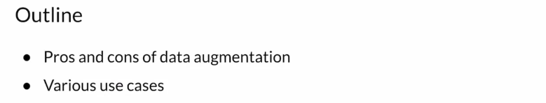
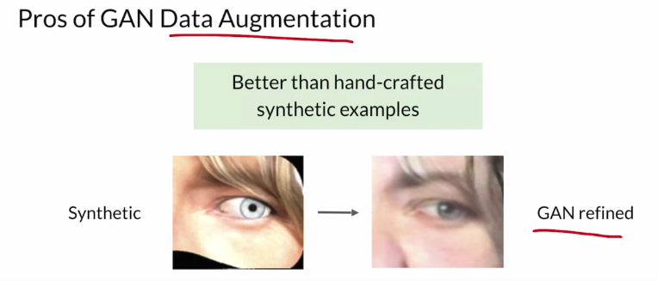
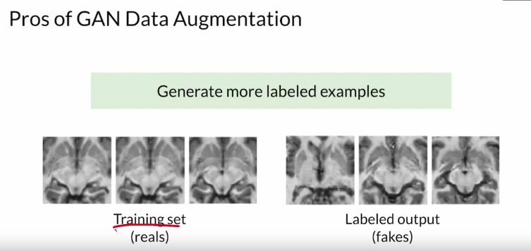

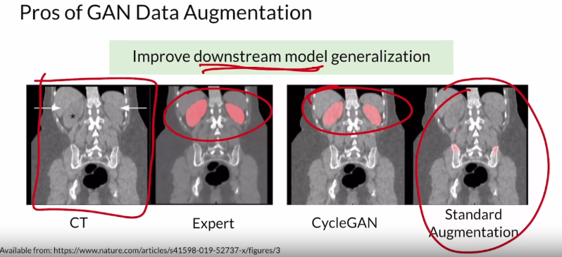
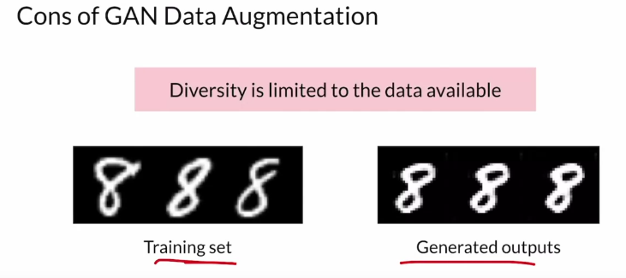

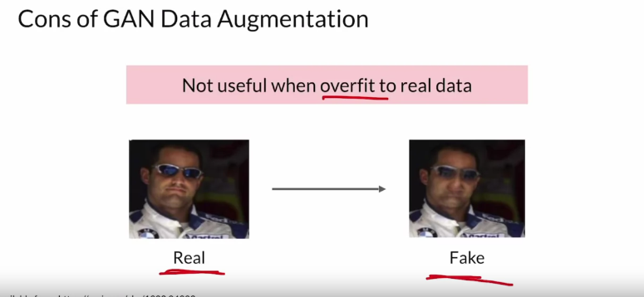

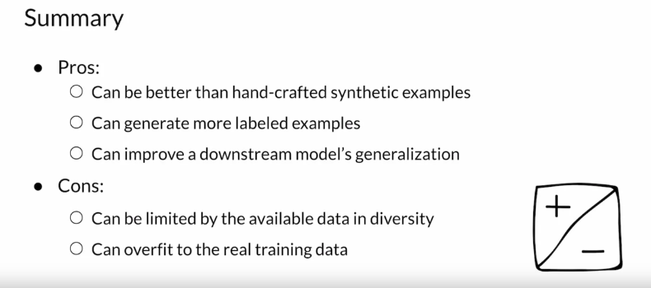

GANs for Privacy
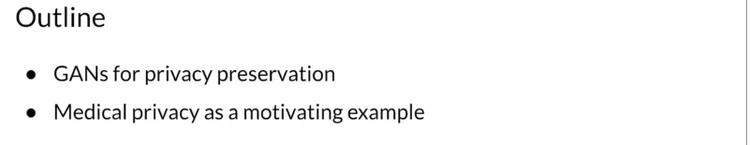

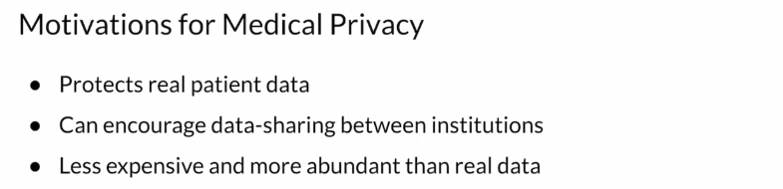
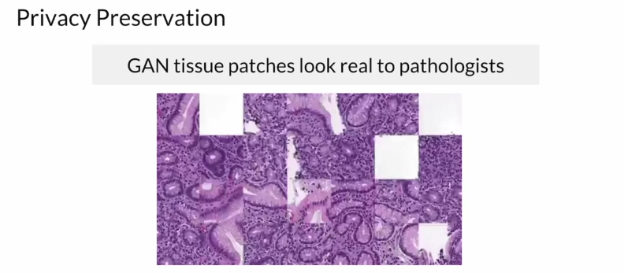
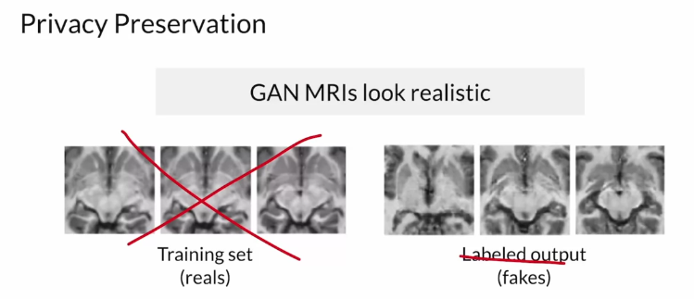
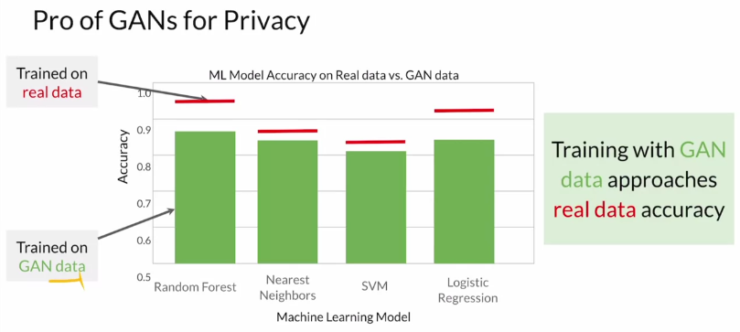

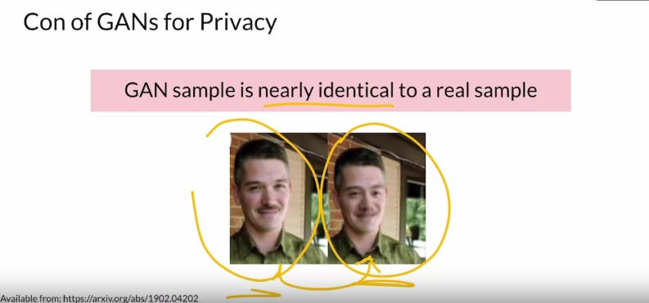
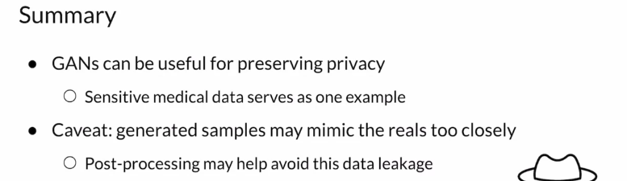

GANs for Anonymity

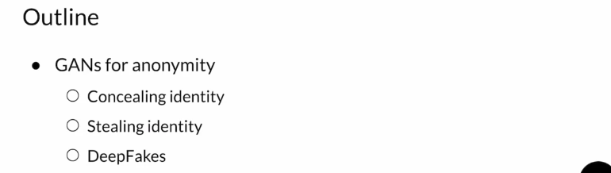

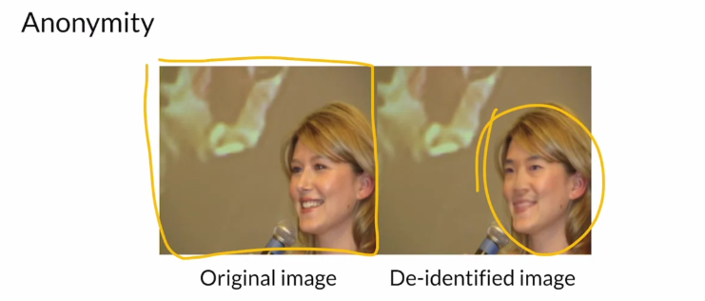
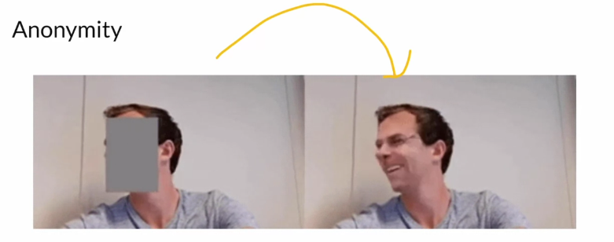
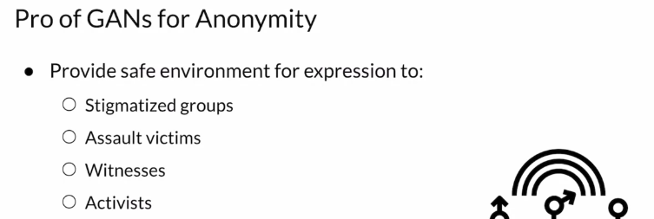

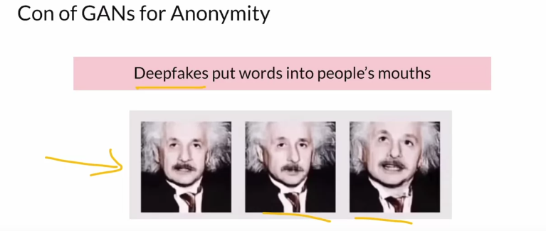

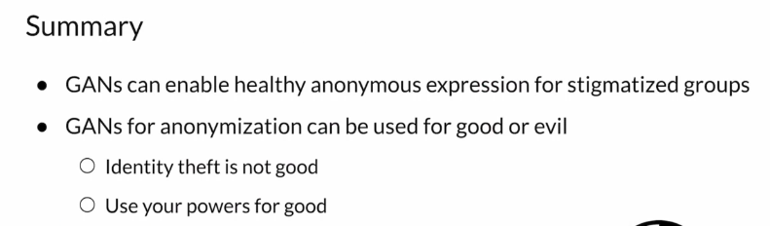

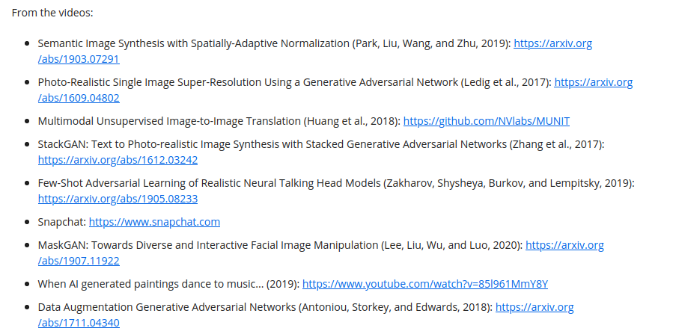
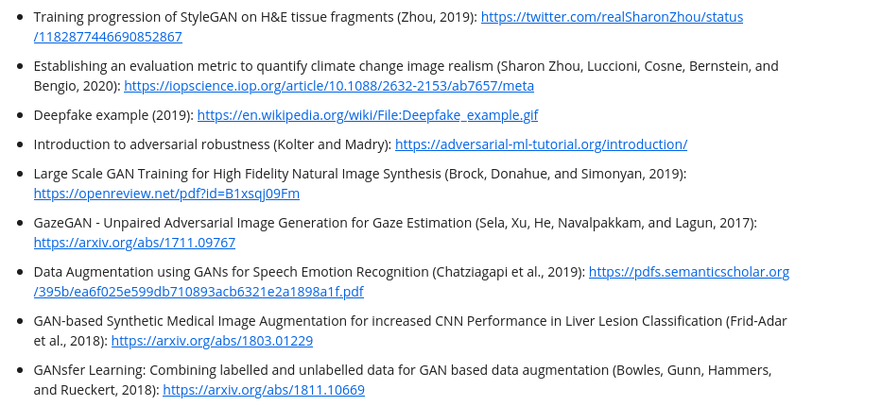
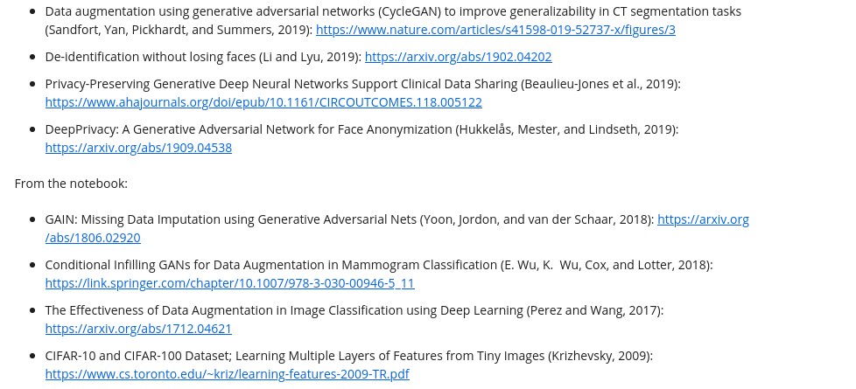

Works Cited

All of the resources cited in Course 3 Week 1, in one place. You are encouraged to explore these papers/sites if they interest you! There are many resources this week and much of it is recent research on emerging uses of GANs. They are listed in the order they appear in the lessons.
From the videos:
- Semantic Image Synthesis with Spatially-Adaptive Normalization (Park, Liu, Wang, and Zhu, 2019): https://arxiv.org/abs/1903.07291
- Photo-Realistic Single Image Super-Resolution Using a Generative Adversarial Network (Ledig et al., 2017): https://arxiv.org/abs/1609.04802
- Multimodal Unsupervised Image-to-Image Translation (Huang et al., 2018): https://github.com/NVlabs/MUNIT
- StackGAN: Text to Photo-realistic Image Synthesis with Stacked Generative Adversarial Networks (Zhang et al., 2017): https://arxiv.org/abs/1612.03242
- Few-Shot Adversarial Learning of Realistic Neural Talking Head Models (Zakharov, Shysheya, Burkov, and Lempitsky, 2019): https://arxiv.org/abs/1905.08233
- Snapchat: https://www.snapchat.com
- MaskGAN: Towards Diverse and Interactive Facial Image Manipulation (Lee, Liu, Wu, and Luo, 2020): https://arxiv.org/abs/1907.11922
- When AI generated paintings dance to music... (2019): https://www.youtube.com/watch?v=85l961MmY8Y
- Data Augmentation Generative Adversarial Networks (Antoniou, Storkey, and Edwards, 2018): https://arxiv.org/abs/1711.04340
- Training progression of StyleGAN on H&E tissue fragments (Zhou, 2019): https://twitter.com/realSharonZhou/status/1182877446690852867
- Establishing an evaluation metric to quantify climate change image realism (Sharon Zhou, Luccioni, Cosne, Bernstein, and Bengio, 2020): https://iopscience.iop.org/article/10.1088/2632-2153/ab7657/meta
- Deepfake example (2019): https://en.wikipedia.org/wiki/File:Deepfake_example.gif
- Introduction to adversarial robustness (Kolter and Madry): https://adversarial-ml-tutorial.org/introduction/
- Large Scale GAN Training for High Fidelity Natural Image Synthesis (Brock, Donahue, and Simonyan, 2019): https://openreview.net/pdf?id=B1xsqj09Fm
- GazeGAN - Unpaired Adversarial Image Generation for Gaze Estimation (Sela, Xu, He, Navalpakkam, and Lagun, 2017): https://arxiv.org/abs/1711.09767
- Data Augmentation using GANs for Speech Emotion Recognition (Chatziagapi et al., 2019): https://pdfs.semanticscholar.org/395b/ea6f025e599db710893acb6321e2a1898a1f.pdf
- GAN-based Synthetic Medical Image Augmentation for increased CNN Performance in Liver Lesion Classification (Frid-Adar et al., 2018): https://arxiv.org/abs/1803.01229
- GANsfer Learning: Combining labelled and unlabelled data for GAN based data augmentation (Bowles, Gunn, Hammers, and Rueckert, 2018): https://arxiv.org/abs/1811.10669
- Data augmentation using generative adversarial networks (CycleGAN) to improve generalizability in CT segmentation tasks (Sandfort, Yan, Pickhardt, and Summers, 2019): https://www.nature.com/articles/s41598-019-52737-x/figures/3
- De-identification without losing faces (Li and Lyu, 2019): https://arxiv.org/abs/1902.04202
- Privacy-Preserving Generative Deep Neural Networks Support Clinical Data Sharing (Beaulieu-Jones et al., 2019): https://www.ahajournals.org/doi/epub/10.1161/CIRCOUTCOMES.118.005122
- DeepPrivacy: A Generative Adversarial Network for Face Anonymization (Hukkelås, Mester, and Lindseth, 2019): https://arxiv.org/abs/1909.04538
From the notebook:
- GAIN: Missing Data Imputation using Generative Adversarial Nets (Yoon, Jordon, and van der Schaar, 2018): https://arxiv.org/abs/1806.02920
- Conditional Infilling GANs for Data Augmentation in Mammogram Classification (E. Wu, K. Wu, Cox, and Lotter, 2018): https://link.springer.com/chapter/10.1007/978-3-030-00946-5_11
- The Effectiveness of Data Augmentation in Image Classification using Deep Learning (Perez and Wang, 2017): https://arxiv.org/abs/1712.04621
- CIFAR-10 and CIFAR-100 Dataset; Learning Multiple Layers of Features from Tiny Images (Krizhevsky, 2009): https://www.cs.toronto.edu/~kriz/learning-features-2009-TR.pdf

